ATK-DLMP257B

Factory system peripheral reuse manual

V1.0

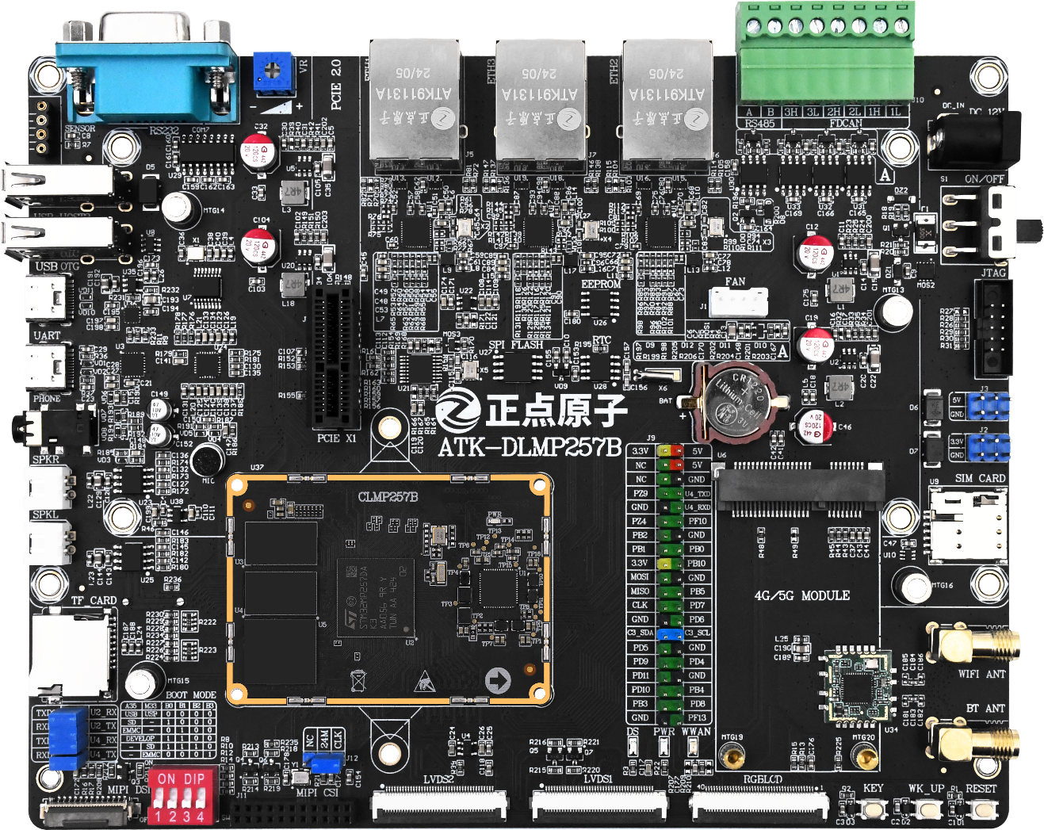



**1. Shopping：**

TMALL：<https://zhengdianyuanzi.tmall.com>

TAOBAO：<https://openedv.taobao.com>

**2. Download**

Address：http://www.openedv.com/docs/index.html

**3. FAE**

Website ：[www.alientek.com](http://www.alientek.com)

Forum ：<http://www.openedv.com/forum.php>

Videos ：[www.yuanzige.com](http://www.yuanzige.com)

Fax ：+86 - 20 - 36773971

Phone ：+86 - 20 - 38271790



**Disclaimer**

The product specifications and instructions mentioned in this document are for reference only and subject to update without prior notice; Unless otherwise agreed, this document is intended as a product guide only, and none of the representations made herein constitutes a warranty of any kind. The copyright of this document belongs to Guangzhou Xingyi Electronic Technology Co., LTD. Without the written permission of the company, any unit or individual shall not be used for profit-making purposes in any way of dissemination.

In order to get the latest version of product information, please regularly visit the download center or contact the customer service of Taobao ALIENTEK flagship store. Thank you for your tolerance and support.

**Revision History:**

|  |  |  |  |  |
| --- | --- | --- | --- | --- |
| Version | Version Update Notes | Responsible person | Proofreading | Date |
| V1.0 | release officially | ALIENTEK | ALIENTEK | 2025.04.01 |

Catalogue

Introduction 1

Chapter 1. Factory source code acquisition and compilation 2

Chapter 2. Multiplexing multiple GPIOs 3

Chapter 3. Multiplexing UART/USART 4

3.1 Confirm that the pin belongs to the UART 4

3.2 Configure the UART master node in the device tree 4

3.3 Configuring UART nodes 5

3.4 Modify the pin reuse configuration 6

3.5 UART function debugging 7

Chapter 4. Multiplexing ADC 8

4.1 Confirm that the pin belongs to the ADC controller 8

4.2 Configure the ADC master node in the device tree 8

4.3 Configure the ADC channel 9

4.4 Modify the pin reuse configuration 10

4.5 Update the device tree to support multiple ADC channels 10

4.6 ADC function test 12

# Introduction

This chapter introduces the methods to configure and reuse a variety of peripherals on the STM32MP257 platform, aiming to help developers make full use of the multifunction pins of the processor, improve the system scalability and hardware reuse rate.

First of all, by obtaining and compiling the factory source code, a complete development environment is established to ensure that the subsequent configuration can proceed smoothly. Then, how to configure and reuse peripherals in the device tree is introduced in detail, including the functional definition of pins, multiplexing Settings and device tree node configuration methods. Through the study of this chapter, developers can master a complete method to configure and reuse common peripherals on the STM32MP257 platform, which provides a solid foundation for the function expansion and hardware optimization of embedded systems.

# Factory source code acquisition and compilation

Before performing all the operations in this document, please obtain the factory source code in accordance with the contents of "\ Development board CD A- Basic information \10_user_manual \" [ALIENTEK] ATK-DLMP257B Factory System Source Code Use Guide V1.0"document, to ensure that the current virtual machine environment can successfully compile the factory source code.

# Multiplexing multiple GPIOs

For the STM32MP257 core board, most of the pins support multiplexing as GPIO functions. In STM32MP2, when an IO pin is used for GPIO functionality, there is no need to create a pinctrl node in the device tree.

In order to reuse the GPIO function of a pin, it is first necessary to verify whether the pin is configured as another peripheral function in the kernel or U-Boot's device tree. If it is, disable the relevant device tree node or comment out the corresponding pin reuse code. Once the pin is released, the high and low levels can be set using the system GPIO command. After the setup is completed, the level change can be tested in combination with the multimeter to confirm whether the pin is working properly.

For detailed operation tutorials, please refer to the development board data path: "Development board CD A- Basic Information \9_tutorials \" [ALIENTEK] ATK-DLMP257 Embedded Linux C Application Programming Guide "document" Chapter 16 GPIO application Programming ".

# Multiplexing UART/USART

## Confirm that the pin belongs to the UART

The STM32MP257 supports up to 9 UART/USART channels and one LPUART channel. When configuring multiplexed UART, special attention must be paid to whether the pin multiplexing defined in the device tree conflicts with other peripherals such as I2C, SPI, etc. If you need to configure separate pins for different UART/USART, you should check the pin multiplexing mapping table of the target chip to confirm that the desired configuration is supported. In order to ensure that the target pin can be reused for UART/USART function, it is recommended to refer to the "ATK-CLMP257B Core Board Interface Data Sheet" for detailed query.

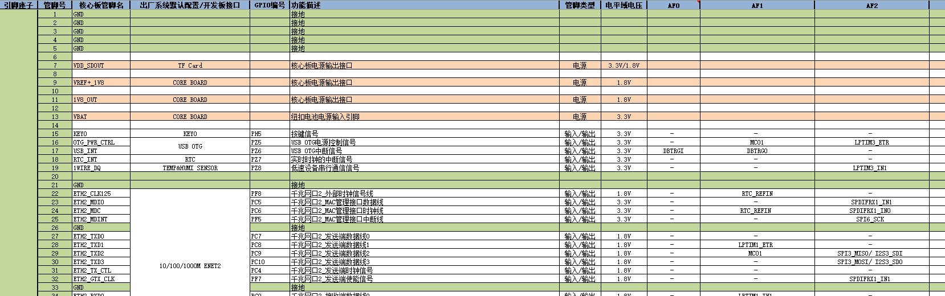

Figure ATK-CLMP257B core board interface data sheet

## Configure the UART master node in the device tree

The device tree file is located at stm32mp251.dtsi, which needs to supplement the UART/USART master node content in stm32mp257d-atk-ddr-1GB.dts or stm32mp257d-atk-ddr-2GB.dts. The specific choice depends on the DDR size of the purchased core board.

Example device tree structure:

stm32mp251.dtsi

usart1: serial@40330000 {

…

};

…

uart9: serial@402c0000 {

…

}；

…

lpuart1: serial@46030000 {

…

}；

## Configuring UART nodes

When configuring the UART device tree node, you can refer to the device tree node of USART2 as an example for configuration. It is particularly important to note that in the default factory sources of the kernel, usart1 and usart2 are set as debug serial ports for serial1 and serial0, respectively. In order to ensure the stability of debugging functions, it is not recommended to modify the default configuration of these two serial ports. For other UART configuration methods, you can directly refer to the device tree of USART2 to modify.

stm32mp257d-atk-ddr-1GB.dts or stm32mp257d-atk-ddr-2GB.dts

…

aliases {

…

serial0 = &usart2;

// By default, USART2 is defined as serial0 and is not recommended to be changed

…

};

…

&usart2 {

pinctrl-names = "default", "idle", "sleep"; // Three pin reuse states are defined

pinctrl-0 = <&usart2_pins_a>; // Pin configuration in default mode

pinctrl-1 = <&usart2_idle_pins_a>; // Pin configuration in idle mode

pinctrl-2 = <&usart2_sleep_pins_a>; // Pin configuration in sleep mode

/delete-property/dmas; // Remove the dmas attribute

/delete-property/dma-names; // Remove the dma-names attribute

status = "okay"; // Enable USART2

};

…

Key configuration explained:

1. **serial0**

Define USART2 as serial0 for the device /dev/ttySTM0.



Figure The serial port pair should be the device file

1. **pinctrl-names = "default", "idle", "sleep";**

Three pin reuse states are defined: default, idle, and sleep mode.

1. **pinctrl-0、pinctrl-1、pinctrl-2**

They correspond to the pin configuration in different modes. The pin configuration is referenced by <&usart2_pins_a>, <&usart2_idle_pins_a>, and <&usart2_sleep_pins_a>.

1. **/delete-property/dmas 和 /delete-property/dma-names**

Remove the dmas and dma-names attributes to indicate that this configuration does not use DMA. Usually DMA is used to speed up data transfer, if not needed, these attributes can be removed to simplify the configuration.

1. **status = "okay"**

USART2 is enabled to indicate that the peripheral is active and ready for use.

## Modify the pin reuse configuration

Add the pinctrl description of the UART pin to the stm32mp25-pinctrl-atk.dtsi file and set its multiplexing function to AFx. The specific AFx value needs to be checked according to the STM32MP257D data sheet or "[ALIENTEK] ATK-CLMP257B Core board Interface Data Sheet" to confirm the correct reuse function number.

stm32mp25-pinctrl-atk.dtsi

usart2_pins_a: usart2-0 {

pins1 {

pinmux = <STM32_PINMUX('A', 4, AF6)>; /* USART2_TX */

bias-disable;

drive-push-pull;

slew-rate = <0>;

};

pins2 {

pinmux = <STM32_PINMUX('A', 8, AF8)>; /* USART2_RX */

bias-pull-up;

};

};

usart2_idle_pins_a: usart2-idle-0 {

pins1 {

pinmux = <STM32_PINMUX('A', 4, ANALOG)>; /* USART2_TX */

};

pins2 {

pinmux = <STM32_PINMUX('A', 8, AF8)>; /* USART2_RX */

bias-pull-up;

};

};

usart2_sleep_pins_a: usart2-sleep-0 {

pins {

pinmux = <STM32_PINMUX('A', 4, ANALOG)>, /* USART2_TX */

<STM32_PINMUX('A', 8, ANALOG)>; /* USART2_RX */

};

};

If we need to reuse other pins as UART, just refer to the above writing of USART2 to modify. The number of the ANALOG mode can be kept the same as the example, except the AFx function number needs to be adjusted according to the definition of the specific pin.

## UART function debugging

After the core board is started, enter the /dev directory of the file system, and you can see the device files corresponding to different serial ports, which are ttySTM0, ttySTM1 and ttySTM2. You can use the serial port function directly from these device files and use tools such as minicom to debug. 

Figure Serial debugging device file

# Multiplexing ADC

STM32MP257 supports ADC1, ADC2, and ADC3, providing a total of 23 channels. Although the ADC of STM32MP257 supports the acquisition of differential signals to improve accuracy, it is usually recommended to select an external ADC chip in order to obtain higher ADC data accuracy. If additional ADC acquisition pins using STM32MP257 are required, they can be configured as follows.

## Confirm that the pin belongs to the ADC controller

First, confirm whether the pin used belongs to the ADC1, ADC2, or ADC3 controller. The STM32MP257 data sheet should be consulted, for example:

* PC5 pin can be used as:
* ADC1_INP10: The 10th forward differential signal input channel of the ADC1 controller
* ADC2_INP10: The 10th forward differential signal input channel of the ADC2 controller
* ADC3_INP10: The 10th forward differential signal input channel of the ADC3 controller
* The PC3 pin can be used as:
  + ADC1_INP12: The 12th forward differential signal input channel of the ADC1 controller
  + Other features are similar

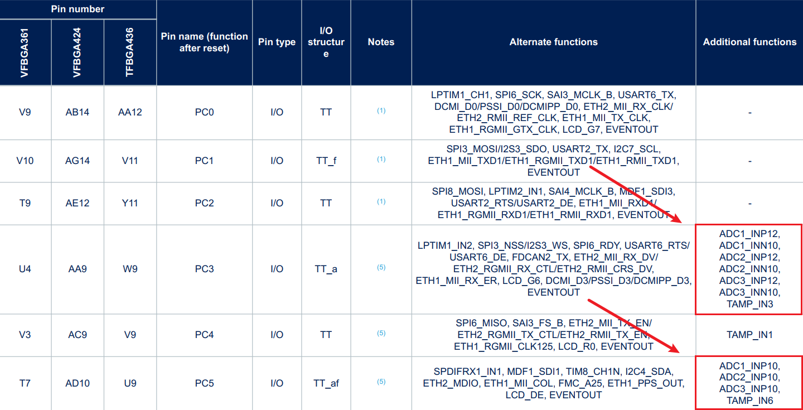

Figure STM32MP257 data sheet

## Configure the ADC master node in the device tree

The device tree file is located in stm32mp251.dtsi, which needs to supplement the ADC master node content in stm32mp257d-atk-ddr-1GB.dts or stm32mp257d-atk-ddr-2GB.dts, depending on the DDR size of the core board purchased.

Example device tree structure:

stm32mp251.dtsi

adc_12: adc@404e0000 {

...

adc1: adc@0 {

...

};

adc2: adc@100 {

...

};

};

adc_3: adc@404f0000 {

...

adc3: adc@0 {

...

};

};

## Configure the ADC channel

Taking channel 15 of ADC1 (ADC1_INP15) as an example, the ADC node in the device tree is configured as follows:

stm32mp257d-atk-ddr-1GB.dts或stm32mp257d-atk-ddr-2GB.dts

&adc_12 {

pinctrl-names = "default";

pinctrl-0 = <&adc1_in15_pins_a>;

vdda-supply = <&vdda_1v8>;

vref-supply = <&vddref_1v8>;

status = "okay";

adc1: adc@0 {

#address-cells = <1>;

#size-cells = <0>;

status = "okay";

channel@15 {

reg = <15>; /* Channel 15 of ADC1 is used */

st,min-sample-time-ns = <10000>; /* The minimum sampling time is 10µs */

};

};

};

Key configuration explained:

1. **pinctrl-0 = <&adc1_in15_pins_a>;**

Reference the pin configuration named adc1 in15 pins a.

1. **adc1: adc@0**

Define the primary configuration node of ADC1, and @0 denotes the address.

1. **channel@15**

Configure channel 15 of ADC1:

* reg = <15>; Specifies that channel 15 is used.
* st,min-sample-time-ns = <10000>; The minimum sampling time was set to 10 microseconds.

## Modify the pin reuse configuration

In the stm32mp25-pinctrl-atk.dtsi file, add the pinctrl description of the ADC pin and set its multiplexing function to "ANALOG".

stm32mp25-pinctrl-atk.dtsi

adc1_in15_pins_a: adc1-in15 {

pins {

pinmux = <STM32_PINMUX('B', 15, ANALOG)>;

};

};

## Update the device tree to support multiple ADC channels

When configuring multiple ADC channels, the master tree file should be updated to include the configuration of all relevant pins. For example, PC3 and PB15 are multiplexed as ADC1_INP12 and ADC1_INP15, PC6 is multiplexed as ADC2_INP6, and PC5 is multiplexed as ADC3_INP10.

The steps are as follows:.

1, modify the pin multiplexing configuration

* Check if there are other device tree nodes using the same pin.
* If a conflict is found, the associated device tree node must be annotated or disabled to avoid pin reuse conflicts.

stm32mp25-pinctrl-atk.dtsi

adc1_in15_pins_a: adc1-in15 {

pins {

pinmux = <STM32_PINMUX('B', 15, ANALOG)>;

};

};

adc1_in12_pins_a: adc1-in12 {

pins {

pinmux = <STM32_PINMUX('C', 3, ANALOG)>;

};

};

adc2_in6_pins_a: adc2-in6 {

pins {

pinmux = <STM32_PINMUX('C', 6, ANALOG)>;

};

};

adc3_in10_pins_a: adc3-in10 {

pins {

pinmux = <STM32_PINMUX('C', 5, ANALOG)>;

};

};

2、Update the kernel device tree

* Configure the channel Settings under the ADC master node to ensure that all required ADC channels have been configured correctly.
* Verify that the pin and register addresses for each ADC channel are set correctly.

stm32mp257d-atk-ddr-1GB.dts或stm32mp257d-atk-ddr-2GB.dts

&adc_12 {

pinctrl-names = "default";

pinctrl-0 = <&adc1_in12_pins_a>, <&adc1_in15_pins_a>, <&adc2_in6_pins_a>;

vdda-supply = <&vdda_1v8>;

vref-supply = <&vddref_1v8>;

status = "okay";

adc1: adc@0 {

#address-cells = <1>;

#size-cells = <0>;

status = "okay";

channel@12 {

reg = <12>;

st,min-sample-time-ns = <10000>;

};

channel@15 {

reg = <15>;

st,min-sample-time-ns = <10000>;

};

};

adc2: adc@100 {

#address-cells = <1>;

#size-cells = <0>;

status = "okay";

channel@6 {

reg = <6>;

st,min-sample-time-ns = <10000>;

};

};

};

&adc_3 {

pinctrl-names = "default";

pinctrl-0 = <&adc3_in10_pins_a>;

vdda-supply = <&vdda_1v8>;

vref-supply = <&vddref_1v8>;

status = "okay";

adc3: adc@0 {

#address-cells = <1>;

#size-cells = <0>;

status = "okay";

channel@10 {

reg = <10>;

st,min-sample-time-ns = <10000>;

};

};

## ADC function test

After the core board is started, enter the /sys/bus/iio/devices directory of the file system, and you can see the devices mounted under different ADC master controllers, namely iio:device0, iio:device1, and iio:device2. It should be noted that the ATK-DLMP257B backboard only supports the test of on-board ADC input (PB15 pin). If other ADC pins need to be tested, the corresponding hardware test scheme should be designed by itself.

cd /sys/bus/iio/devices

ls -l



Figure List of ADC controller devices

It can be seen from Figure 4.6.1 that the corresponding ADC controller register addresses of each device. In the stm32mp251.dtsi device tree file, the register addresses of ADC1 to ADC3 master controllers are indicated, which is convenient to quickly locate and measure the device files under different ADC master controller channels.

|  |  |
| --- | --- |
| ADC controller Controller | ADC controller Controller register address |
| ADC12 | adc@404e0000 |
| ADC3 | adc@404f0000 |

Once the configuration is complete and restarted, the ADC data can be read using the following command:

cat /sys/bus/iio/devices/iio:device0/in_voltage12_raw

cat /sys/bus/iio/devices/iio:device0/in_voltage15_raw

cat /sys/bus/iio/devices/iio:device1/in_voltage6_raw

cat /sys/bus/iio/devices/iio:device2/in_voltage10_raw

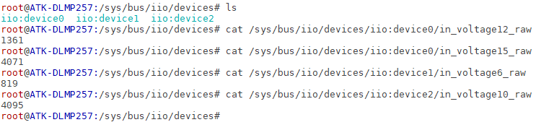

Figure Read voltage acquisition analog

Or use the watch command to monitor all ADC channels in real time:

watch -n 1 "echo ADC1_INP12: \$(cat /sys/bus/iio/devices/iio:device0/in_voltage12_raw) && echo ADC1_INP15: \$(cat /sys/bus/iio/devices/iio:device0/in_voltage15_raw) && echo ADC2_INP6: \$(cat /sys/bus/iio/devices/iio:device1/in_voltage6_raw) && echo ADC3_INP10: \$(cat /sys/bus/iio/devices/iio:device2/in_voltage10_raw)"



Figure The watch instruction detects the ADC channel



Figure ADC channel monitoring results show